Movies Database – Movies and Actors

We have been given the task of creating an online resource based on movies produced in the last 50 years.

One of the features of this resource will be a RDMS that will store details of the personnel and production information relating to a large number of films.

We have an Excel file provided with data that has been partly normalised in that some of the entities and their attributes have already been identified.

However one of the sheets on the Excel file labelled Movies and Actors still needs to be normalised before it is suitable for the RDMS.

Screenshots can be seen below of this table and its attributes.

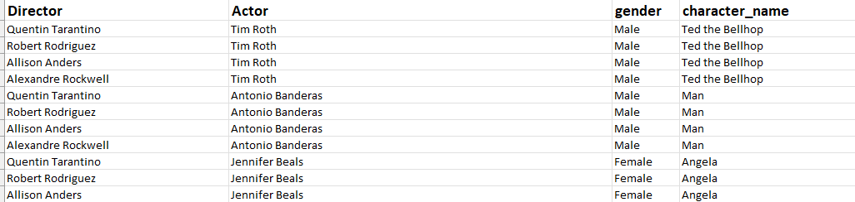

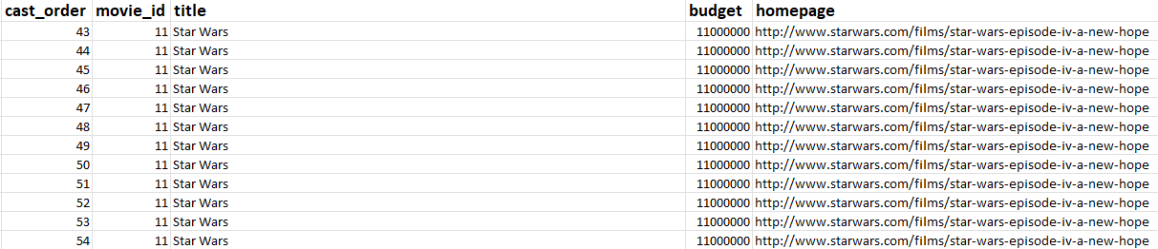

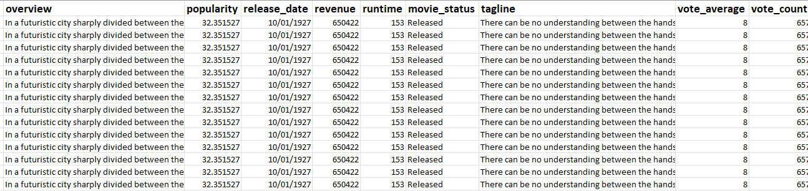

Task 1

The attributes in the Movies and Actors table are:

Director
Actor
gender
character_name
cast_order
movie_id
title
budget
homepage
overview
popularity
release_date
revenue
runtime
movie_status
tagline
vote_average
vote_count

Identify and name potential entities from the information supplied.

Remember that there may be many-to-many relationships between the tables that would require a bridging table (a table containing the foreign keys of the tables to be joined)

Think about the fact that and actor can play many characters but these characters can appear in a number of movies i.e. Luke Skywalker appears in Star Wars but also in The Empire Strikes Back!

Also when you create any of the main tables from they will need a Primary Key attribute that may need to be added for example director_ID
Identify and name potential entities from the information supplied.

Hint:

There are at least 5 entities needed and 2 of these are bridging tables.

- Director
- DirectorMovie
- Movie
- ActorDetails
- Character

Task 2

Compile data dictionaries for your identified entities.
You may use the pro forma on the following page (or any other valid format).
You should include any Keys (Primary and Foreign), Data Types for each attribute and any suitable constraints I.e. Null, Not Null

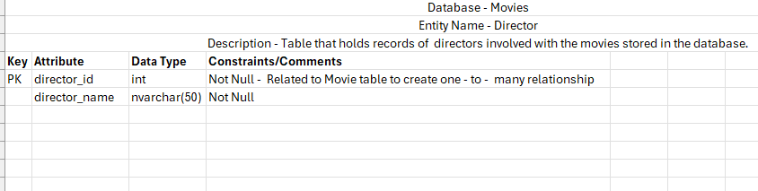
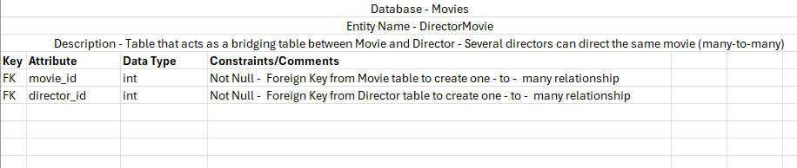
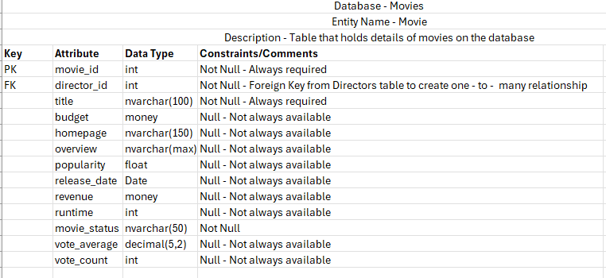
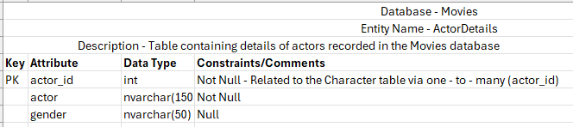
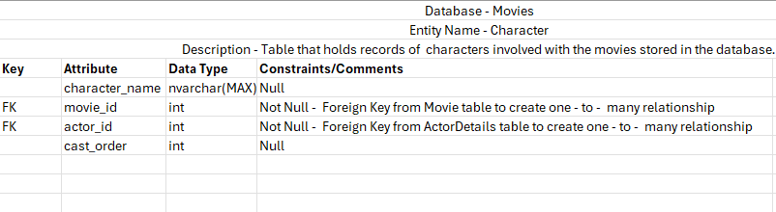
Task 3

Identify entity relationships. Draw an Entity Relationship Diagram showing the relationships (cardinality) between the entities(tables) you identified in Task 1.

Show the Primary and Foreign keys to show how tables would relate to each other i.e. The Primary key of one table (Parent) would become the Foreign key in its related table (Child)
